Revamping “Kingdomestaterealty.com” High Requirement v1.1
Date: 5\18\17
High Level objective:
- Slick looking website where prospect is comfortable to hang around long enough to provide their first, last name and email address (tel – optional)
- Able to capture the above info, so that we could follow up later (either through their search or contact us or a pop up dialog box to capture their info while they amazed by the bells and whistles which keep them around, such as below:
  - Nice scrolling homes/sceneries (residential)
  - Good looking commercial investment sites (when they click on commercial button)
  - Able to easily search for properties (Residential and some commercial)
  - Scrolling testimonies
  - Mortgage calculator (may be)
  - Changing boxes (bottom center) for Frisco and McKinney
  - Logo and link to Facebook, Blog and LinkedIn
  - Providing Free Home Estimate (not sure how to do this yet?)- In order to get free home estimate, they will need to provide their info (name, address, email and phone (optional).
  - BLOG for Q and A; FB referral etc.

- See screenshot for basic layout (Second layer will be detailed out in the next phase of requirement i.e. v1.2)
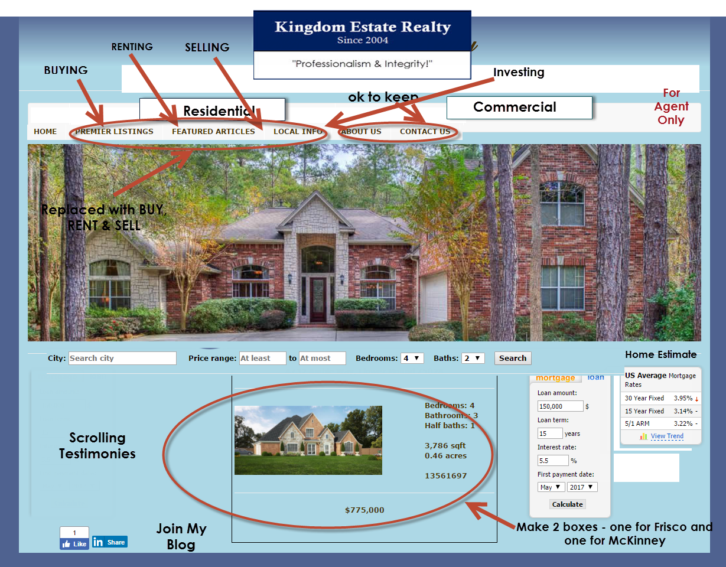

In summary (5\17\17): - we will refine more as we go, here is just a start
- Want to have a “For Agents” may be at top right corner of menu bar, serving two purposes:
  - Have my agents (current I have a couple) sign in with their credentials for more confidential information
  - Solicit agents which are interested in joining the team (plan to sponsor 20 agents in next 10 years)
- There are dual purpose of my site:
Primary – Prospective Clients
When visitors“stumble” upon my site, I would like them to stay long enough to provide info and we could then convert this contact into potential leads (Leads generation 24x7)

  - We also want them to be able to save what they saw on particular house, If he likes the house, then, they can Tag house (i.e. saved, like or mark) but will need to fill up
  - A simple form on Right (First, last name, and email, tel. is optional but told them we won’t call them but could text them their favorite searches status?) or to receive more info.
  - We collect prospect contact info → Capture the lead and follow up with Email within 24 hours/or Text the prospect for similar houses he may be interested in, Or else, Just merely browsing and not save any homes, then …. How do we capture their behaviors and try to get their contacts with pop up like some of the sites? Any idea?
  - Provide some “free” stuffs (Home Estimation) but they will need to give their first and last name with email address (Tel – optional but won’t call them will text them when estimate is ready)
  - Want visitors to help spread the words (by sharing on facebook etc.)
  - Target cities are Frisco, Plano, McKinney and Allen and cities that touch them (i.e. prosper, little elms as well)
  - Bottom line is – we want to convert the visit into potential leads to follow up (24x7), making the online technology work for us
Secondary – Prospecting Good Agents to be sponsored
    - That is why we have the “For Agent” only button. To attract talents to help build Kingdom Estate Realty for next 10 years and beyond. More to come and will keep second layer simple as well. Will talk more
Hope this makes sense.
---------------------------------------------------------------------------------------------------------------------
Jess’ initial response (after first cut on concept around 5/12/17)
Screenshot #1: The concept of a cleaner looking site with more images (rotating) of homes is popular now for sure. You can see it on ebby.com and you can see it on mine @ http://easleyrealty.com too.
CH: ok

Screenshot #2: For the current listings, these are obviously your listings and you have all of the info on them. We can format that and present it any way you like. For the open houses, I would think you would want that to be dynamic and real-time with actual open houses. Question is: Where does the data feed come from? Do you have licensing to query the MLS directly?
CH: We could work with CCAR IT forks that I know

Screenshot #3: KW is interesting. It's really the same as Ebby's but with a slight twist to make it more focused on buyers. That's the target market for these after all...sellers aren't on these web sites that much. We can do any of this stuff.
CH: ok

Screenshot #4: Dynamic images...no problem. See my site for more examples. You would have to decide on the artwork and how you wanted to manage changing it going forward. For mine, I chose not to change it. It does what it needs to do. Mileage may vary.
CH: ok, will look for both residential and commercial slides for you in the coming days

For agents: We can definitely have authentication so they could have a better tool set. Just have to decide on what's underneath that layer.
CH: ok, let’s keep it real simple to start with - I have some ideas and will share as we start

General thoughts:
- This is all pretty high level thinking, as it should be at this point. Will have to flush out the details as it goes.
- Also would like you to consider mobile. Websites are for buyers to search for houses. The do that A LOT while they're in the care looking at houses, so the phone is an important part of the equation today. CH: Sound good
- Yes, users can save their searches. We know if we make them log in, we can cache their searches in a db and then they can look at them from anywhere. We know users don't want to log in, so we'll have to use cookies to save searches. That means they can't go to work and look at the searches they saved at home. Something to think through.
CH: no worries about work place, I think people do thing at work during lunch as well
- Contact when a status changes will be the most difficult I think. Consider de-prioritizin this. We don't have bots that can run on the server processing changes, we just have web pages. If you want to navigate to a page every day to kick off this job, they may be more doable, but if we're saving searches in cookies,,,that's on the users's machine...we won't know what to give them updates on. May be more of an argument to having them create an account. CH: Let’s drop this one for now, I think if I get their contact info, I can always follow up
- Sharing on social media. It's an easy thing to plug that in. A lot of realtors have landing pages on the social media sites too now.
CH: will be learning more about fb and watching video on how to do that. This is one is on me but we just need access from fb to my website and vice versa, correct?
- I'm not sure what your site is built on top of right now. It may be template based, which gives us less control over some of these features...or maybe it does and I just don't know how to do it 🤔. I think you have to agree to settle for something less than what you're asking for here, if you go with template based. Ebby's site was redesigned just a couple of years ago, and it's all custom now...not sure if it was before.
Just some thoughts...sorry for going long. I'm busy a couple of times during the day, but free a lot of it too. What's your availability?
Jess Easley
(972) 284-9403

5/12/17: More Detailed design (1)
Main dialog box -- > city, house prices (i.e. min to max), # of bed room, # of bath [enter] → list of potential homes (may be limit of 10) →
Option 1:

